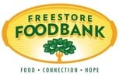 | FREESTORE FOODBANK  Partnerships and Programs
 | Push Produce

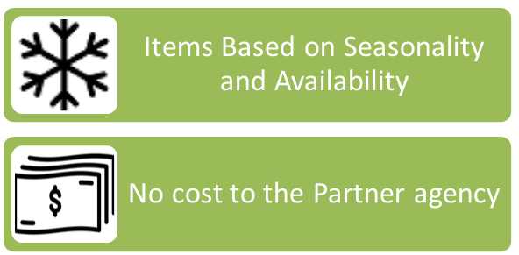  Complete the Form Below to Get Started | 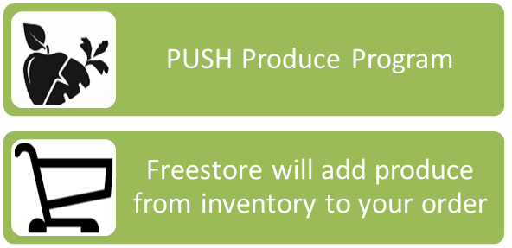

Agency name:  Delivery day:  Item Pack/size Quantity  Apples 8/5lb  Cabbage Banana Box  Carrots Banana Box  Corn Banana Box  Cucumbers Banana Box  Green beans Banana Box  Greens Banana Box  Onions 16/3lb  Oranges Banana Box | Item Pack/size Quantity  Peaches Banana Box  Peppers Banana Box  Potatoes 5/10lb  Squash Banana Box  Sweet potatoes Banana Box  Tomatoes Banana Box  Watermelon Tote (as seen in stores)  Zucchini Banana Box  Peppers Banana Box

