How to Register to the Annual Freestore Foodbank Hunger Walk
Step by Step Instructions

- Go to the Hunger Walk website at www.cincinnatihungerwalk.org
Keep in mind that the particular design of the website could change every year, though the general registration steps will remain the same.
- You can either pick a team, register as an individual, or organize your own team.
- To pick a team click on the top menu or scroll down until finding the “Join a Team” button.
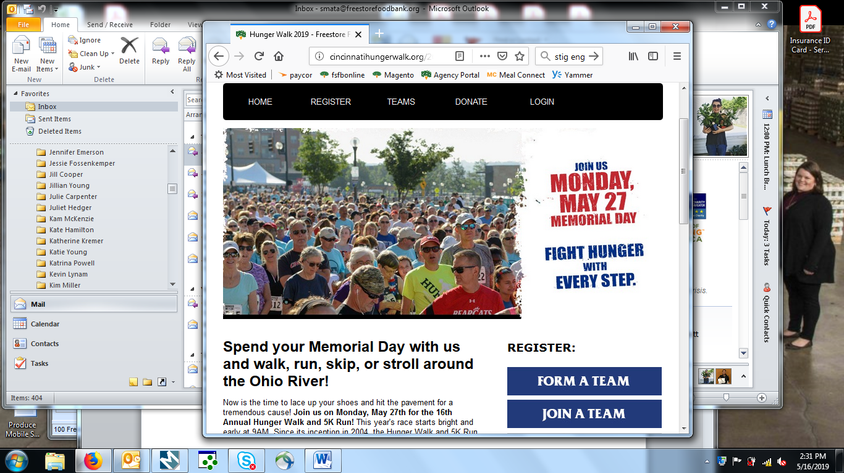
A page with the list of participating teams will come next; scroll down and find the team you want to join either by the team’s name or the captain’s.
- If instead of choosing an existing team you want to register as an individual, click “Register” on the top menu or scroll down until finding the “Register as an individual” button.

- Or if you would prefer to create your own team, you may choose that option scrolling down the page until finding the “Form a Team” button on the right.
If you have decided to form your own team, you will have to choose the Freestore Foodbank partner agency you want to help with your enrollment fee by selecting it from the dropdown menu shown below. Remember that if you do not make this choice, your contribution will benefit the Freestore Foodbank directly instead. You will also have the oportunity to name your team, and set both your personal and team fundraising goals.
- Once you have chosen between joining a team, creating one, or simply registering as an individual, complete the Participation Options form, in which you’ll be able to get a Hunger Walk shirt, enter a discount code if you have one, and make an additional contribution to the Freestore Foodbank if that’s your choice.
- Now it’s time to enter your personal details. Click on “Join as a New Participant” unless you have already created a Username and Password in the Hunger Walk website, in which case you may enter your login credentials on the right side of the screen.
- The next screen will allow you to enter your name, gender, and age, as well as your contact information and that of an emergency contact. You will also be able to choose your size of shirt, and create a Username and Password for this website. Remember to write down your login information and keep it in a safe place for future reference.
- Once you’ve entered your personal information, the terms and agreements document must be acknowledged on the next page. Simply check the box that says you agree with the terms, and go to the next step.
- The following page will allow you to review your order or add a family member to the race. If you’re satisfied with the order description on the screen, you may click on “Complete Registration” to enter your credit card information.
- Complete the following form with your credit card information, your name and your billing address, as you would with any other online purchase.
And that is it, you’ve done it! You will see a confirmation page with the description of your registration, your tracking code , and a payment receipt. You will also see a button that links to your Participant Center, where you will be able to track your both your personal and team fundraiser goals. You will also receive all this information for your records in an email just a few seconds after completing the transaction.
*
As an alternative method to complete your registration, you may submit your payment via check. Simply scroll dow the website until you see a link labeled “Print Registration Form (PDF)” on the right of the page; click on it to download the form for you to complete by hand. Once you have completed it, you may mail it to the Freestore Foodbank at 1141 Central Parkway, Cincinnati OH, 45202 with the corresponding check.
If you have any further questions or you need any additional assistance to participate in the Hunger Walk, you may contact you Agency Relations Coordinator at the Freestore Foodbank.
Thank you for participating!

