Agencies are required to submit monthly statistics reports through the Agency Portal. These reports are required for the state and for internal purposes. They can impact funding, so it is important that all agencies submit accurate reports every month. If an agency does not submit their report by the 5th of the month following their distribution, a follow up email should be sent. If they still do not submit their report, their next event will be placed on hold.
There are a few options for collecting the data for monthly reports. The recommended way is Pantry Trak. This is a web-based registration program. Agencies that use Pantry Trak will only have to input client information once and the website will store that information for future visits. Pantry Trak will also compile the data for agencies to submit. IT WILL NOT SUBMIT THE INFORMATION TO AGENCY PORTAL. It will only give the information; the agency will still have to submit through the agency portal.
If an agency does not have internet access, they can use paper TEFAP eligibility forms to track clients. These forms collect the same information as Pantry Trak. Agencies can keep these on file and just have clients sign them every visit. These will then need to be counted and submitted through the agency portal. TEFAP eligibility forms can be found on the Tennessee shared drive : \\ten-fileserver\shared\Agency Services\Agency Relations\USDA\FY2018_OH TEFAP\Eligibility Forms7-1-2018
The last option is a sign in sheet. There is a form on the shared drive that can be used or agencies can use their own. They will need to track number of people in household by age and total number of people in the household. The age breakdowns are birth-17, 18-59 and 60+. These numbers will need to be totaled and submitted through agency portal. The sign in sheet can be found on the Tennessee shared drive: \\ten-fileserver\shared\Programs Team\Processes\Produce Pop Ups\Forms\Blank forms
Logging into the Portal

• Agencies logging in for the first time must REGISTER. Click on REGISTER, CREATE PASSWORD, and follow prompts.

Website
www.cincinnatifoodbank.org/agencyportal

Creating User ID

• Select the ‘Register’ icon on the login screen

• Fill in the blanks and CREATE A PASSWORD.

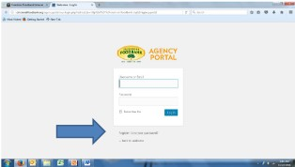

• Once agency is logged in, the WELCOME screen will appear.

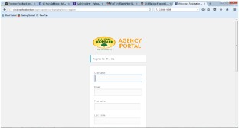

Using the Portal

The Freestore Portal the following uses
- Will have updates and news regarding the Freestore Foodbank and Community Partners
- Will be a hub for submitting various reports

Viewing Updates

At the top of the screen will be pictures and links to the most recent news items.

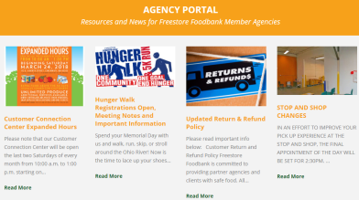

Submitting Statistics Reports

• Scroll down the page to MONTHLY STATISTICAL REPORT FORMS.
• Click on MONTHLY STATISTICAL REPORT FORMS.
• Select the report to be completed. Reports are identified by STATE

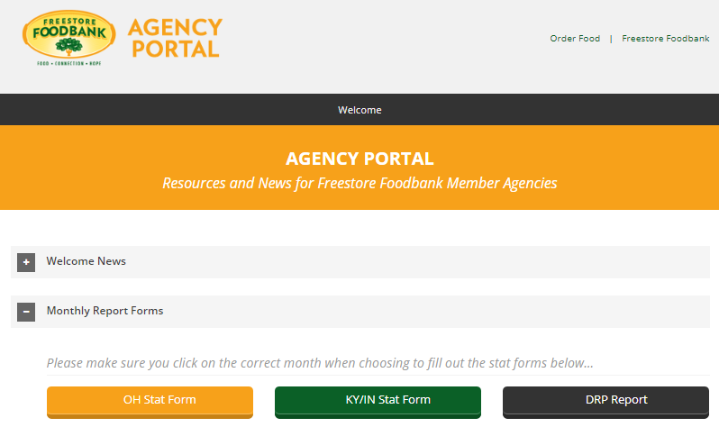

Submitting Statistics Reports (Continued)

• Choose appropriate month to report. Fill in the blanks and follow prompts.

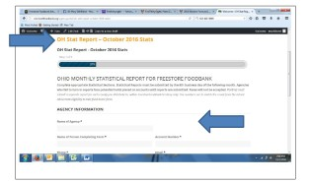

• Select appropriate COUNTY and click NEXT.
- Note: If your organization serves households from multiple counties, a separate report must be submitted for each county

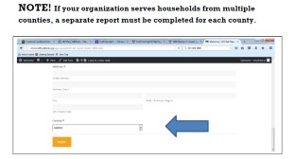

Submitting Statistics Reports (Continued)

• Fill in statistics. Enter number and tab to next category.
• Click ‘Next’
• Fill in the statistics if your organization is a MEAL SITE or SHELTER. When finished, click NEXT.
- If your organization is NOT a MEAL SITE or SHELTER, click NEXT to move forward.

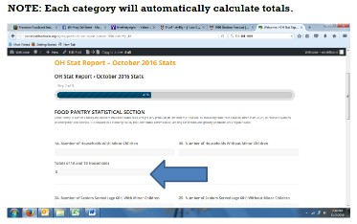

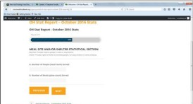

• Click NEXT

Submitting Statistics Reports (Continued)

• Fill in the statistics if your organization provides CONGREGATE and/or RESIDENTIAL meals.
• When finished click NEXT.
- If your organization does not provide CONGREGATE and/or RESIDENTIAL meals, click NEXT to move forward.

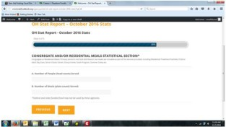

• Fill in the statistics if your organization hosted a Pop-Up Event during this month

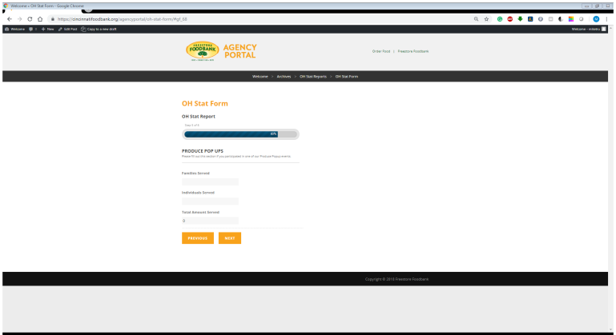

• When finished click NEXT.
• Enter any comments
• When complete, click SUBMIT
• A screen will appear confirming that submission is COMPLETE.

