FREESTORE FOODBANK
CSFP (Senior Box) Operations Manual
Partner Information
POA / Guardianship Information

POA / Guardianship

Freestore Foodbank and the Government understands that due to the limitations of some of the individuals in which we serve, Power of Attorneys (POA) or Legal Guardianships may need to be setup to best serve those in need. If a senior in need has a POA or guardian, the guardian must provide appropriate paperwork along with the application and recertification

The application that the senior initially completes includes a section to complete to assign a proxy on the first page. This section should be completed for the POA / guardian as well.

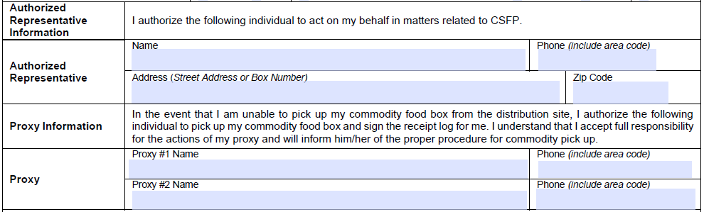

By completing this section, this would allow for up to two individuals to be assigned as a proxy for a senior.
- If the senior needs more than two proxies, a second application with only the proxy information can be filled out by the senior.

