FREESTORE FOODBANK
CSFP (Senior Box) Operations Manual
Partner Information
Proxy Information

Proxy

Freestore Foodbank and the Government understands that due to the limitations of some of the individuals in which we serve, proxies may need to be setup to best serve those in need. A proxy is someone who acts in behalf of another person. With regards to CSFP distribution, a senior may assign one or more individuals who are authorized to receive the products on behalf of the senior, and who will be responsible for bringing the product to the senior.

The application that the senior initially completes includes a section to complete to assign a proxy on the first page.

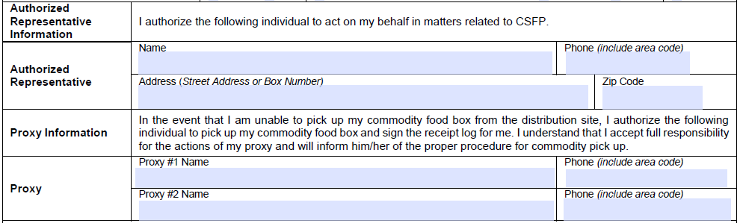

By completing this section, this would allow for up to two individuals to be assigned as a proxy for a senior.
- If the senior needs more than two proxies, a second application with only the proxy information can be filled out by the senior.

