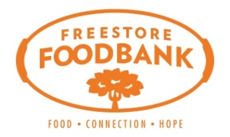 | FREESTORE FOODBANK  CSFP (Senior Box) Operations Manual
 | Partner Information
 | Sample – Termination

Sample Letter

[Date and Time]

[Applicant Name]:

After careful review of your information for the Commodity Supplemental Food Program (CSFP) we have determined that your current entitlements are being terminated due to one of the following eligibility guidelines: Income Guidelines, County of Residence, or Failure to Recertify Correctly.

The guidelines to determine eligibility for the Commodity Supplemental Food Program are established by the United States Department of Agriculture and require all participants to be 60 years or older, reside in Hamilton County and have a gross income not exceeding 130% of the poverty line:

Household Size | Monthly Income
1 | $1,354
2 | $1,832
3 | $2,311
4 | $2,790

You were ineligible to receive CSFP Entitlements due to:
Income Ineligibility
Not a Resident of [County]
Did Not Submit Recertification Application

[Agency] will undergo an annual application process in [Time Frame] if you choose; you can re-apply for the CSFP at that time. [Agency] will announce that applications may be open at that time.

If you think the information used to determine your ineligibility for CSFP is incorrect, please contact [Agency] at the contact information below.

Sincerely,

[CSFP Coordinator]
[Agency]
[Contact Information]
[Date and Time]

